**MANCHESTER TANK Financial Acquisition - Group 6**

Jerry Hsu, Chethan Mittapalli, Erin Janklow, Amit Bhatia, Adam Allen

**Table of Contents**

1. Part I – Definitive Agreement
2. Part II – Binding Provisions
3. Part III – Supporting Information
   1. Degree of Interest
   2. Strategy Post-acquisition
      * 1. Increase domestic sales for 4 product lines
        2. Make Australian acquisition
        3. Sell Lubbock plant and cut the water heater product line
   3. Management Strategy
   4. Management of Australian Subsidiary
   5. Valuation and Bid Price
   6. Financing
   7. Sources and Uses of Funds
   8. Return on Investment
   9. Due Diligence
   10. Day 1 Strategy

**PART ONE**

The Parties wish to commence negotiating a definitive written acquisition agreement providing for the Possible Acquisition (a “Definitive Agreement”). To facilitate the negotiation of a Definitive Agreement, the Parties request that the Buyer’s counsel prepare an initial draft. The execution of any such Definitive Agreement would be subject to the satisfactory completion of the Buyer’s ongoing investigation of the Target Companies’ business, and would also be subject to approval by the Buyer’s board of directors.

Based on the information currently known to the Buyer, it is proposed that the Definitive Agreement include the following terms:

**1. Basic Transaction**

The Seller would sell all of the outstanding capital stock of the Company to the Buyer at the price (the “Purchase Price”) set forth in Paragraph 2 below. The closing of this transaction (the “Closing”) would occur as soon as possible after the termination of the applicable waiting period under the Hart-Scott-Rodino Antitrust Improvements Act of 1976 (the “HSR Act”).

**2. Purchase Price**

Mittapalli Capital proposes to purchase 67% ownership of Manchester Tank for a bid price of $43,774,000 subject to the terms of this Letter of Intent, based on a valuation of $78M, which includes 7% premium of $5,259,000.  We have a moderate degree of interest in this firm as we see several opportunities to increase earnings; namely, to increase sales in the gas grill tank, air receiver, chemical cylinders and rail cars; make an acquisition in Australia; and cut costs by selling off the Lubbock plant and dropping the water heater product line.  The cost-cutting measures are not part of the current management’s strategy, and we therefore plan to control a super-majority of the company in order to make these changes.  We will finance this purchase (including the partial acquisition of the Australian company for an additional $6.775M in 1996) with $23M in equity, $15.47M in additional ABL (Revolver), $6M in working capital cushion, $8M in an earn out for the owners that is contingent on meeting 90% of revenues, and $10M in mezzanine financing.  This acquisition and strategy will yield an IRR of 50% for Mittapalli Capital within 5 years. We propose to keep the existing debt of $12.66M intact and take additional ABL debt of $15.57M to finance the deal.

**3. Employment and Noncompetition Agreements**

At the Closing:

(a)Sellers shall be required to remain in the company for three years as executive vice presidents to a CEO appointed by the Buyer.

**(**b) Upon leaving the Company after three years, Sellers would execute a three-year noncompetition agreement in favor of the Buyer and the Company.

(c) Quigley will receive a $8 MM earn out, to be distributed after three years contingent on 90% of 1998 revenues targets being hit.

(d) Other managers and employees shall remain in their positions with at-will status for both chief officers and the Buyer.

**4. Other Terms**

The seller would make comprehensive representations and warranties to the Buyer, and would provide comprehensive covenants, indemnities and other protections for the benefit of the Buyer.

**PART TWO**

The following paragraphs of this letter (the “Binding Provisions”) are the legally binding and enforceable agreements of the Buyer and Seller.

**1. Access**

During the period from the date this letter is signed by the seller (the “Signing Date”) until the date on which either Party provides the other Party with written notice that negotiations toward a Definitive Agreement are terminated (the “Termination Date”), the Seller will afford the Buyer full and free access to each Target Company, its personnel, properties, contracts, books and records, and all other documents and data.

**2. Exclusive Dealing**

Until the later of (i) [90] days after the Signing Date or (ii) the Termination Date:

**(a)** the Seller will not and will cause the Target Companies not to, directly or indirectly, through any representative or otherwise, solicit or entertain offers from, negotiate with or in any manner encourage, discuss, accept, or consider any proposal of any other person relating to the acquisition of the Shares or the Target Companies, their assets or business, in whole or in part,  whether directly or indirectly, through purchase, merger, consolidation, or otherwise (other than sales of inventory in the ordinary course); and

**(b)** The seller will immediately notify the Buyer regarding any contact between the Seller, any Target Company or their respective representatives and any other person regarding any such offer or proposal or any related inquiry.

**3. Break-up Fee**

If (a) the Seller breaches Paragraph 2 or the Seller provides to the Buyer written notice that negotiations toward a Definitive Agreement are terminated, and (b) within [six] months after the date of such breach or the Termination Date, as the case may be, either Seller or one or more of the Target Companies signs a letter of intent or other agreement relating to the acquisition of a material portion of the Shares or of the Target Companies, their assets, or business, in whole or in part, whether directly or indirectly, through purchase, merger, consolidation, or otherwise (other than sales of inventory or immaterial portions of the Target Companies’ assets in the ordinary course) and such transaction is ultimately consummated, then, immediately upon the closing of such transaction, the Seller will pay, or cause the Target Companies to pay, to the Buyer the sum $150,000. This fee will not serve as the exclusive remedy to the Buyer under this letter in the event of a breach by the Seller of Paragraph 2 of this Part Two or any other of the Binding Provisions, and the Buyer will be entitled to all other rights and remedies provided by law or in equity.

**4. Conduct of Business**

During the period from the Signing Date until the Termination Date, the Seller shall cause the Target Companies to operate their business in the ordinary course and to refrain from any extraordinary transactions.

**5. Confidentiality**

Except as and to the extent required by law, the Buyer will not disclose or use, and will direct its representatives not to disclose or use to the detriment of the seller or the Target Companies, any Confidential Information (as defined below) with respect to the Target Companies furnished, or to be furnished, by either Seller, the Target Companies, or their respective representatives to the Buyer or its representatives at any time or in any manner other than in connection with its evaluation of the transaction proposed in this letter. For purposes of this Paragraph, “Confidential Information” means any information about the Target Companies stamped “confidential” or identified in writing as such to the Buyer by the seller promptly following its disclosure, unless (i) such information is already known to the Buyer or its representatives or to others not bound by a duty of confidentiality or such information becomes publicly available through no fault of the Buyer or its representatives, (b) the use of such information is necessary or appropriate in making any filing or obtaining any consent or approval required for the consummation of the Possible Acquisition, or (c) the furnishing or use of such information is required by or necessary or appropriate in connection with legal proceedings. Upon the written request of the seller, the Buyer will promptly return to the seller or the Target Companies or destroy any Confidential Information in its possession and certify in writing to the seller that it has done so.

**6. Disclosure**

Except as and to the extent required by law, without the prior written consent of the other Party, neither the Buyer nor either Seller will, and each will direct its representatives not to make, directly or indirectly, any public comment, statement, or communication with respect to, or otherwise to disclose or to permit the disclosure of the existence of discussions regarding, a possible transaction between the Parties or any of the terms, conditions, or other aspects of the transaction proposed in this letter. If a Party is required by law to make any such disclosure, it must first provide to the other Party the content of the proposed disclosure, the reasons that such disclosure is required by law, and the time and place that the disclosure will be made.

**7. Costs**

The Buyer and each Seller will be responsible for and bear all of its own costs and expenses (including any broker’s or finder’s fees and the expenses of its representatives) incurred at any time in connection with pursuing or consummating the Possible Acquisition. Notwithstanding the preceding sentence, the Buyer will pay one-half and the seller will pay one-half of the HSR Act filing fee.

**8. Consents**

During the period from the Signing Date until the Termination Date, the Buyer and Seller will cooperate with each other and proceed, as promptly as is reasonably practical, to prepare and to file the notifications required by the HSR Act.

**9. Entire Agreement**

The Binding Provisions constitute the entire agreement between the parties, and supersede all prior oral or written agreements, understandings, representations and warranties, and courses of conduct and dealing between the parties on the subject matter hereof. Except as otherwise provided herein, the Binding Provisions may be amended or modified only by a writing executed by all of the parties.

**10. Governing Law**

The Binding Provisions will be governed by and construed under the laws of the State of New York without regard to conflicts of laws or principles.

**11. Jurisdiction: Service of Process**

Any action or proceeding seeking to enforce any provision of, or based on any right arising out of, this Letter may be brought against any of the parties in the courts of the State of New York, and each of the parties consents to the jurisdiction of such courts (and of the appropriate appellate courts) in any such action or proceeding and waives any objection to venue laid therein. Process in any action or proceeding referred to in the preceding sentence may be served on any party anywhere in the world.

**12. Termination**

The Binding Provisions will automatically terminate on July 31, 1995 and may be terminated earlier upon written notice by either party to the other party unilaterally, for any reason or no reason, with or without cause, at any time; provided, however, that the termination of the Binding Provisions will not affect the liability of a party for breach of any of the Binding Provisions prior to the termination. Upon termination of the Binding Provisions, the parties will have no further obligations hereunder, except as stated in Paragraphs 2, 3, 5, 7, 9, 10, 11, 12, 13 and 14 of this Part Two, which will survive any such termination.

**13. Counterparts**

This Letter may be executed in one or more counterparts, each of which will be deemed to be an original copy of this Letter and all of which, when taken together, will be deemed to constitute one and the same agreement.

**14. No Liability**

The paragraphs and provisions of Part One of this letter do not constitute and will not give rise to any legally binding obligation on the part of any of the Parties or any of the Target Companies. Moreover, except as expressly provided in the Binding Provisions (or as expressly provided in any binding written agreement that the Parties may enter into in the future), no past or future action, course of conduct, or failure to act relating to the Possible Acquisition, or relating to the negotiation of the terms of the Possible Acquisition or any Definitive Agreement, will give rise to or serve as a basis for any obligation or other liability on the part of the Parties or any of the Target Companies.

If you are in agreement with the foregoing, please sign and return one copy of this letter agreement, which thereupon will constitute our agreement with respect to its subject matter.

**PART THREE**

**Degree of Interest**

We see Manchester Tank as the clear leader in the steel and aluminum tank and cylinder market.  Although acquiring yet more of the market share will be increasingly difficult, we see opportunities for growth both domestically and internationally.  The company’s key strengths include product quality and innovation, strong customer relationships, and brand equity with a 50-year track record.  Although their top competitors dwarf Manchester Tank in size, we believe that their relentless focus on the tank and cylinder industry has led to their market leadership and has laid the groundwork for a profitable future.  At the same time, we see several new opportunities for growth in international markets as well as increased operational efficiency – simultaneously trying to leverage the firm with additional debt while keeping the existing debt of $12.66M intact.

**Strategy and Assumptions**

Our strategy for Manchester Tank post-acquisition includes growing domestic sales beyond the current rate for the following product lines: Gas grill tank, Air receiver, Chemical cylinders, and Rail cars. We will further acquire a plant in Australia, and sell the Lubbock plant while dropping the water heater product line.

**Growing domestic sales for product lines:**

* Gas grill tanks
  + Of our three current customers, two are not purchasing exclusively from us, and we will invest $450,000 in sales and marketing each year to increase more sales to these customers. We estimate that sales for this product line will increase by 10% each year, starting in 1997, as opposed to the base case estimate of 6% each year, resulting in 16% higher sales in 2000 for this product line, or a cumulative $15.8M additional sales over the 5-year period.  We will also increase production in Indiana from 50% of operating capacity (currently) to 75% to fulfill the additional demand.
* Air Receivers
  + We will close a deal with Ingersoll in 1997 so that sales in the Air Receiver line will increase by 5% each year, starting in 1998, as opposed to the base case estimate of 1% each year. Manchester Tank’s engineering team will modify our products to match Ingersoll’s needs (a $200,000 investment in 1996), and a Mittapalli Capital board member has close ties with Ingersoll’s CEO, which will facilitate the deal.  This will result in a cumulative $5.2M in additional revenues from Ingersoll by 2000.  We will increase production in the Missouri plant from 50% of operating capacity to 65% to fulfill this demand.
* Chemical Cylinders and Rail Cars
  + We see more room for growth in both the chemical and rail car markets, and we will invest an additional $100,000 to increase our total sales in those lines by an average 4% growth each year.  The large chemical shipping tank production in Texas will be moved to the Indiana facility, and rail car production will continue in Ontario.

**Australia Acquisition**

* We see tremendous opportunity to sell Manchester Tank’s best-in-class products in developed markets abroad.  Australia offers the most immediate opportunity for a return, and we plan to move ahead with management’s decision to purchase a small manufacturing and distribution company there.  With sales of $12M annually, and applying our similar valuation mechanism as in Manchester Tank for $12M sales, we will bid $6.775M to purchase 100% of this company by year-end 1995 and begin making the $12M in sales in 1996.  We will pay the $6.775M in 1996 with Cash. We anticipate our sales growth to follow Australia’s market rate of 11% per year.  We will also invest $335,000 in startup costs, which is double the initial startup investment of the company’s 1992 acquisition.
* We will service the Australian and New Zealand markets with the manufacturing done from our Australia acquisition. All remaining international exports will be distributed from our US manufacturing plants. We assume that costs will decrease for Australia and New Zealand. Costs may increase for sales to South America, as the Lubbock plant will no longer be in service (see below).

**Cost-Cutting**

We see two immediate opportunities for cost-cutting at Manchester Tank--selling off the Lubbock Texas plant (while increasing percent of operating capacity production in Indiana and Missouri) and dropping the water heater line altogether.

* Selling off Lubbock
  + The company’s Lubbock, Texas plant is the least efficient U.S. plant by both revenues per square feet ($158,000) and revenues per employee ($99,000).  Producing the smallest number of units per year per plant (26,000 units) and operating at half its capacity, this plant is the best option to sell off, and we will shift its production to other plants with excess capacity.  We will move Lubbock’s production of chemical and compressed air tanks to Indiana and its alternative fuel production to Ontario.  We expect to lose one quarter of the revenues of the Lubbock plant in 1996 assuming delays in increasing our percent of operating capacity at Indiana, but will resume the regular growth rate of sales by 1997.  Indiana’s operating capacity will increase from 50% to 75% to accommodate both the added production of chemical and compressed air tanks as well as the increased demand for gas grill tanks.
  + Because Lubbock is currently about 60% as efficient as Indiana, we expect to save $2.3M per year in the selling of this plant.  This amount is 20% of Lubbock’s contribution to total COGS, which we believe we can save as we transfer production to more efficient plants.  We assume the selling price of the land, facility, and machinery will compensate for the costs of relocating machinery and transferring production to other plants.  We will also provide a severance/relocation package of $30,000 to each of our 94 Lubbock employees.
  + The elimination of the Lubbock plant will decrease growth in 1996. We predict that the changes will be ready to take effect in the beginning of 1997.
* Cutting the Water Heater line
  + We will cut the water heater line from our product mix after 1996.  This line has had a negative CAGR since 1992 and will save us $1.9M over four years.  The main reason for cutting this line is to open up production space in the Crossville plant and warehouse to meet the growing demand of the propane cylinder market.  Since this plant is already at 90%, opening up capacity by dropping the water heater line will prevent additional costs from shifting this production to our Indiana plant.

**Base Case vs Strategy Case Assumptions for each Product Line**

|  |  |  |
| --- | --- | --- |
| **GROWTH ASSUMPTIONS** | **Base Case** | **Strategy Case** |
| RV cylinders | Limited RV market growth | No change |
| Gas Grill cylinders | Maintain market share | Increase sales to two customers by 10% per year |
| Mass Merchandising | Steady 7% growth | No change |
| Air receivers | Steady 1% growth | Acquire Ingersoll as new customer - Increase sales by 5% per year |
| Propane cylinders | Market growth at 8% | No change |
| Forklift cylinders | Market growth at 8% | No change |
| Fire Suppressant cylinders | Mgmt projections | No change |
| Chemical cylinders | 1% market growth, no reliance on new regulation to spur sales | Average 4% growth each year |
| Railcar tanks (a) | Mgmt projections | Acquire new customers, 4% growth each year |
| Water heaters | 3% market growth | Dropping water heater line |
| Other (b) | 2% market growth | No change |
| Alternative | No growth | No growth |

**Management Strategy**

Our private equity firm will appoint a new CEO to manage the strategic direction of the company and appoint both brothers to executive vice president positions. The rest of the management team will be given the option of staying with the firm.

We will purchase 67% of the company and offer the following incentive package so that they will be willing to work as operational consultants rather than as strategic leaders:

|  |  |  |
| --- | --- | --- |
|  | Incentive Description | Incentive Amount |
| 1 | PE Firm buys 67% Stake in Manchester Tank from the brothers for $43M |  |
| 2 | PE Firm will recruit a restructuring expert to be CEO to execute the new strategy and the brothers will help him in the restructuring strategy. | PE firm will provide 1% equity to the new CEO if he achieves the strategy at the end of 4 years |
| 3 | Brothers will be demoted to Executive Vice President Position and will help in operations of the company | Incentive to demote would be the earn outs, bonuses and post valuation of 33% equity at the end of 3 years |
| 4 | Earn Out to Brothers:  Meet 90% Revenues for 3 years.  Earn out will start from Year 2. | $8M in 3 years |
| 5 | Premium paid to Brothers for buying their company | 7% |
| 6 | Bonus: If Brothers help new CEO to meet 100%+ Revenues in 3 years, we will give them $8 Million at end of 3 years | $8 Million in Cash |
| 7 | Brothers valuation of 33% at the exit will be much higher and should be a good incentive to execute the strategy | Approx. $46MM for 33% of the total valuation in year 2000, almost equivalent to 67% of the current valuation |

Item #7 on the list above, the potential sell-off value by 2000, is explained in this table below:

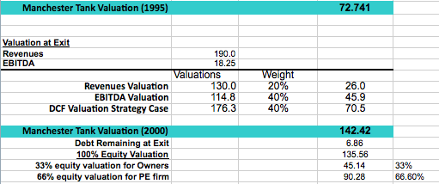

**Management of Australian Subsidiary**

Challenges for the Australian acquisition include: (1) Integration with the management team (2) Increased costs for travel and communication (3) Integration of financial systems (4) Time change (5) Cultural differences.

The immediate acquisition of this company will result in $12MM in revenues in 1996, and we anticipate year by year sales to increase at the market rate of 11%.

The Australian Acquisition will act independently. The acquisition will be used primarily for increased production and reduced shipping costs for Manchester Tank.  However, one current member of Manchester will be sent to the Australian offices in order to implement the process of TQM to keep costs as low as possible while continuing to provide a high quality product.

Providing the acquisition goes according to plan, we (the PE decision makers and the brothers) will first visit the Australian team to understand their operations and identify areas where we believe they could improve. Then, we will invite the entire Australian management team to our headquarters in Tennessee and take them on a tour of a production plant in order to explain how our processes are executed.

The trip will accomplish the following objectives:

1. Provide an opportunity for the consultant and new management team members to mesh with the current management team.
2. Allow the Australian team to understand the processes and operations that we implement and become familiar with TQM.
3. Provide opportunities for informal bonding, establishing a common rapport for future encounters.
4. Set additional goals for the next 5 years as a team, creating buy-in from the management to work with us in our endeavors.

The challenge of incorporating cultural differences specific both to countries as well as companies cannot be overlooked. The case has provided no reason to believe that any current member of the management team has a multicultural view or approach to solving problems, nor much experience with different cultures in general. While Australia does not provide a language barrier, the Tennessee-based team will have many lessons to learn surrounding life and norms “outside America.” We believe, though, that the increased revenues and growth of the Australian market will ensure a strong return.

**Valuation and Bid Price**

We valued Manchester Tank by taking a weighted average of a revenues multiple (20%), an EBITDA multiple (40%), and our discounted cash flows calculations (40%) based on our best estimates of status quo operations (“base case”), as follows:

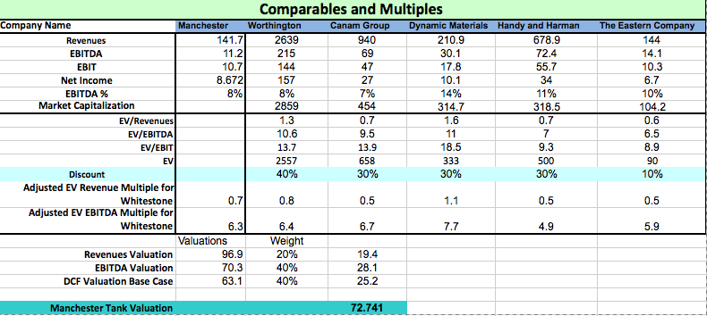

Other valuation assumptions include the following:



Our bid price is $43,774,000 to buy 67% of the company. This is assuming a total value of $78M that includes a 7% premium and additional funding to purchase Australian Acquisition for $6.775M that includes a 10% premium and $6M working capital cushion.  So, we need a total of $56.5M to finance the entire deal with acquisition and working capital cushion.

These are the assumptions for Base case and Strategy.

**Financing the Acquisition**

Given the following valuation and bid price, Mittapalli Capital will acquire the following sources of funds, as follows:

|  |  |  |  |
| --- | --- | --- | --- |
| **Entity Valuation with EV Revenue Multiple** | | $96,943 | |
| **Entity Valuation with EV EBITDA Multiple** | | $70,281 | |
| **DCF Valuation Base Case** | | $63,092 | |
| **DCF Valuation with Strategy** | | $1,76,253 | |
| **Valuation with weighted average** | | $72,741 | |
| **Final Price for entire company** | | $78,000 | |
| **Premium (7%)** | | $5,259 | |
|  | |  | |
| Current Debt | | $12,666 | |
|  | |  | |
|  | **Options** | | **Equity Purchase Price** | |  |
| 1 | Buy out 50% | | 32667 | | 50% |
| 2 | Buy Out 100% | | 65335 | | 100% |
| 3 | Buy out more than 51% to gain Control | | 43774 | | 67% |
|  |  | |  | |  |
|  | **Select OPTION (1,2,3)** | | 3 | |  |
|  |  | |  | |  |
|  | Bid number | | **43,774** | |  |
|  | (Australian Acquisition) | | 6775 | |  |
|  | Working capital cushion | | 6000 | |  |
|  | Total Funds required | | 56,549 | |  |
|  |  | |  | |  |
|  | **Sources Of Funds** | |  | |  |
|  | Equity | | 23,000 | | 40.7% |
|  | ABL loan | | 0 | | 0.0% |
|  | Revolver | | 15,549 | | 27.5% |
|  | Earnout | | 8,000 | | 14.1% |
|  | Mezzanine | | 10,000 | | 17.7% |
|  | Total | | 56,549 | | 100.0% |
|  | Total Debt | | 33,549 | |  |

We assume we can qualify for an ABL loan and revolver at 80% of AR, 50% of inventory, 50% of the FMV of fixed assets, at 10% interest. We qualify for a maximum of $42.87 and will utilize ABL revolver of $15.5M and keep the existing $12.6M debt in the company, as we still would be well below the ABL max amount.

**Sources and Uses of Funds**

|  |  |  |
| --- | --- | --- |
| **Sources Of Funds** |  |  |
| Equity | 23,000 | 40.7% |
| ABL loan | 0 | 0.0% |
| Revolver | 15,549 | 27.5% |
| Earn out with 90% revenue target | 8,000 | 14.1% |
| Mezzanine | 10,000 | 17.7% |
| Total | 56,549 | 100.0% |
| Total Debt | 33,549 |  |

|  |  |  |
| --- | --- | --- |
| **Uses Of Funds** |  |  |
| Payment to owners for 67% equity | 43,774 |  |
| Working capital growth cushion | 6,000 |  |
| Australian Acquisition | 6,775 | 10% premium for $12M company |
| Total | 56,549 |  |

**Earn out**

The earn out will be $8M (i.e. 14% of the bid price) paid in 3 years with payments starting during second year. This earn out is tied up to achieving 90% of revenues.  We have valued the company with 90% revenues and have taken the difference in valuation to cover with the earn outs. This $8M will protect us if our company does not hit our revenues projections in three years. If we do hit 90% of our revenues projections, we can afford to offer the earn out.

|  |  |  |  |
| --- | --- | --- | --- |
| **NPV (Base Case)** | **63092** |  |  |
| **NPV with 90% revenues** | **59749** |  |  |
| **IRR (Base Case)** | 19% |  |  |
| **Earnout** | **8,000** | Tied with 90% revenues | |
| **Difference between earn-out and base case NPV** | 3343 |  |  |

The mezzanine loan will be at 7.5% interest; 7-year term with 7.5% paid in kind and the principal payment will start from 5th year. Mezzanine loan is an important piece in debt structure, as we wanted to cover EBIT interest coverage in the first few years by increasing the mezzanine loan, and we believe this will be a very attractive to the mezzanine investors.

Our financing payment schedule is as follows: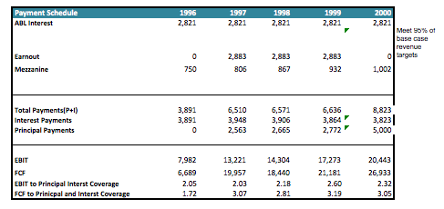

**Due Diligence**

If allowed to progress into further negotiations, the team will examine the following areas:

1. It is of utmost importance to assess the brothers’ willingness to truly let go of the company’s control. While we recognize the large successes they have led at the company, we hold a different vision. We need to be sure that we have their support, goodwill, and guidance, and that their leadership and willingness to adapt will be translated to the rest of the management team.   
   We will ask the following questions to assess feasibility:
   1. When is the last time you worked in tandem with someone else?
   2. How do you react when you disagree with other team members? Please provide examples.
   3. What is your preferred leadership style?
   4. Do you agree with the new direction we envision for the company? What problems do you foresee and what solutions would you recommend in its place?

Much of the conversation will be behavioral, and will be crucial in assessing the brothers’ ability to be led by the consultant we will put in place.

1. Also of importance is to assess the Management Teams, both in the US as well as Australia. We will rely heavily on the leadership and agreeability of the brothers, and believe that if they present believable acceptance of our strategy, the team will acquiesce. This needs to be proved. To understand this, we will ask questions such as:
   1. What is your strategic approach? What variables do you assess when moving the company forward? Who do you usually consult? How many members are involved in the process? What do you do when you disagree with a strategy proposed? How do you react if your idea is not followed? We will ask for examples of each.
   2. Regarding Australia, we need to assess the degree of willingness to participate in the acquisition. Is it a friendly deal? Are the current managers capable? Questions will include: What about Manchester Tank particularly excites you? How have you previously grown the company, and what are your current plans for growth? What is the degree of flexibility you are willing to grant an outside corporation? We will also want the chance to speak with all candidates after reviewing their resume. We assume capability, but want the chance to confirm on our own.
2. Australian acquisition target:
   1. We would investigate thoroughly their current acquisition plan, including capability of the joint-venture, how JV is evaluated, how JV would construct, and how important decision is made along the way.
   2. According to current plan, we could further determine whether 11% growth in our assumption is realistic.
3. Cost cutting: Is this feasible? Do our projections allow the company to function as smoothly as possible? As the company already subscribes to TQM, is it possible to implement new systems in existing plants? The following is the task to answer the questions
   1. We will need to see blueprints of the current plant structure and work with the Chief of Operations in order to assess condensing the Lubbock plant into two other areas. If this is possible, we will be quite pleased. A deep analysis of both cost and time required will help us to better project growth revenues. It is possible that one year is too much time to allow for operations to run smoothly.
   2. Further, we need to understand what current machinery is unutilized at existing plants and if they have multiple functions.
   3. We will further investigate the cost of transporting machinery across the company and assess if it is more lucrative to do this than to buy new machinery. This requires a better understanding of the operations.
   4. Finally, at first glance the company airplane seems entirely superfluous. We will perform an assessment to the number and frequency of travel by the team, compute average ticket prices over the last year, and determine if flying a private company jet is simply a drag on finances or if the true benefits are unquantifiable.
   5. We understand that company claims to have the highest quality of products. We would be actually checking out reports of their quality, the quality control process, inventory management system, etc. We also would like to assess their relationship with suppliers and customers, the buying patterns of raw material and digging deeper in their supply chain.
   6. We also would like to visit the plants and distribution centers and assess the ground situation. We would like to speak with the plant managers to understand brief overview of their operations. We will also need to see purchase of machinery and other heavy equipment to make sure we account for any such adjustments in our valuation.
4. A more substantial examination of financials is required. We noticed a substantial increase in profits over the last year, and we want to be sure that this was due to improvements in process, acquisitions, and cost reductions as indicated in the case. There is the chance that changes in the accounting process, a reduction of “company expenses” for personal use, or perhaps even fraudulent activities have been performed so as to appear attractive to a new buyer. While we do not distrust current management, we are suspicious of the true finances of the company.

* We will need detailed information of the customers list for each product line. This is to understand the trend of each production line and also to understand if 1995’s growth is sustainable.
* We take careful look at the impact on new system and see how it affected efficiency.
* We would also want to investigate further on all non-recurring items to understand the gap of 1995 and 1994

**Day 1 Strategy – In addition to Due Diligence, we will begin the first day on the job in this way:**

1. Schedule a meeting with the owners of the Australian firm to begin preparations for the joint venture.
2. Work on a PR plan for the sale of the Lubbock Texas plant so that Manchester’s customers will see the change in a positive light. (if validated positively in our DD process)
3. Tour the Crossville Tennessee plant to introduce ourselves to managers, talk to employees, and observe how the plant is run at 90% capacity (two-shifts).
4. Hold an all-company meeting after lunch in order to clearly communicate the new vision and plans to the current employees. Doing so immediately will reduce the chance for rumors to spread. Introduce our new management board to employees.
5. Have lunch with the leadership team to ask and answer questions about our management philosophy.
6. Schedule a trip to the Indiana facility to see how the plant runs at 50% capacity (single-shift) and what changes will need to take place to increase to 75% capacity.

Exhibits:

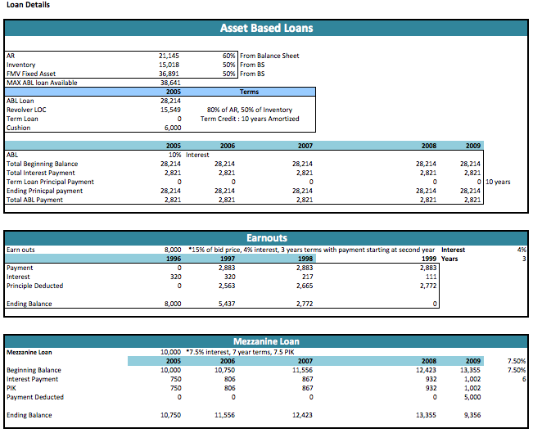

Pro-Formas illustrating assumptions and the financial impact of our strategy on each product line:

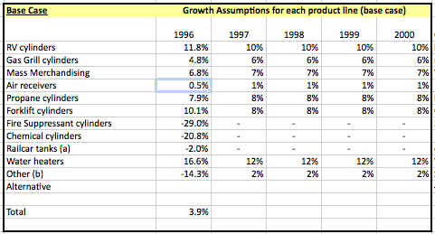

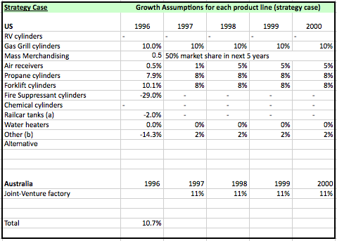

Pro Forma Income Statement:



Assumptions for Income Statement:

|  |  |  |  |
| --- | --- | --- | --- |
| **Assumptions for non-recurring items** | |  |  |
|  |  |  |  |
|  |  |  |  |
|  |  |  |  |
| $450 | To sell more product to two major customers | |  |
| $200 | $200K in engineering to meet Ingersoll product specs | | |
| $100 | $100K in sales and marketing for moderate gain in Chem and Rail | | |
| 10% | reduction each year |  |  |
| 30% | reduction each year |  |  |
| 5% | reduction each year |  |  |
|  |  |  |  |
| 6775 | valuation of $6.7M using valuation mechanism of Manchester Tank paid in cash with 10% premium |  |  |
| 2 | 2x the startup costs as the 1992 acquisition | |  |
| 1% |  |  |  |
|  | 9.6 |  |  |
|  | 20% of COGS attributed to Lubbock saved in efficiency at Indiana | | |
| 30 | $30,000 each in severance for 94 TX employees | |  |
|  |  |  |  |
|  |  |  |  |

Balance Sheet for Strategy Case:



DCF Valuation with Strategy and Assumptions



WACC Calculation for Strategy Case:

